English Language Arts 30-1
Miss. Bronwyn Kierstead
St. Andrew’s School
High Prairie, AB
Room 103
English Language Arts 30-1 is a prepatory course for students who are planning on attending post secondary education. It is strongly suggested that students, who attained below 60% in English Language Arts 20-1, register in English Language Arts 30-2 instead of English Language Arts 30-1. Please make sure that you are taking the right English course for you.
There are two basic aims of senior high school English Language arts. One aim is to encourage in students, an understanding and appreciation of the significance and artistry of literature. A second aim is to enable each student to understand and appreciate language and to use it confidently and competently for a variety of purposes.
ELA 30-1 Outcomes:
Students will read, write, listen, speak, view and represent to:

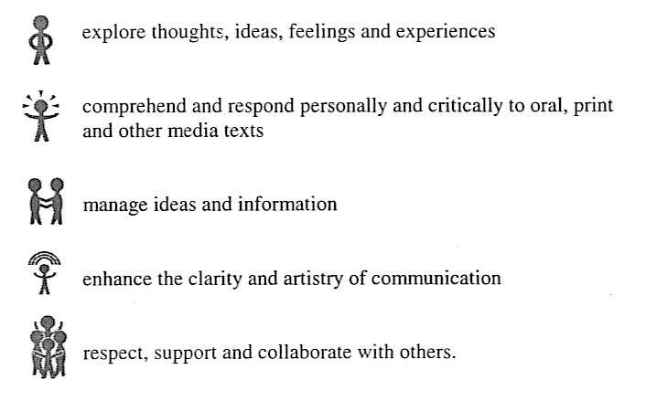
Evaluation

Class Evaluation Course Evaluation
Process 20% Class Mark 50%
Product 30% Diploma Part A 25%
Unit Evaluation 50% Diploma Part B 25%
Evaluation Policies
All testing will follow the rules set forth by Alberta Learning for Diploma exams.
- All examinations materials such as pens, dictionaries and thesauruses must be brought with the students to class. Sharing of materials or communication of any kind is not permitted and those doing so will receive a mark of zero(0).
- All exam and quiz question books remain the property of the English Department, thus will not be given to the students.
- Students are responsible for making sure they are present for all exams, fast-writes and quizzes otherwise, they will be given a mark of zero (0). These may be deferred only when exceptional circumstances prevent the student from writing at the scheduled time. (sleeping in, Car trouble etc. do not constitute exceptional circumstances). Advance notice must be provided whenever possible.
- Major exams have been scheduled at the completion of each unit. Quizzes and assignments have not been scheduled, nor has the total number been determined.
- Assignments must be neat and legible, they may be typed or hand written in blue or black ink. Major assignments must be double spaced: a title page and working copy must be included.
- Assignments that included plagiarism or copying from another student will receive a mark of zero (0); in the latter case, both the copier and the “copiee” will receive zero (0).
- Late work will be penalized 25% per day. Extensions of due dates will be given only under special circumstances.
- If a student has questions about the grading of an assignment, the teacher must be notified within two days of receiving the graded assignment.
Textbook & Supplies
Students will be assigned the textbook Echoes 12 for the duration of the semester as well as several other textbooks for which they will be responsible. If a student fails to return an assigned textbook, no further textbooks will be provided until the original is paid for and returned.
The following items should be brought to class every day:
- Three ring binder and lined paper
- Pens (blue or black ink)
- Dictionary
- Thesaurus
English Language Arts Tentative Year Plan
All units will be thematic. Each Unit will include assignments and activities and a mixture of genre of texts and contexts
Unit Themes | Classes | Texts
Unit 1&2 Grammar Review and Confronting Conflict  - Poems, Shorts, Essays and Grammar Review | Sept.- October | Grammar Review Booklet  Echoes 12 Textbook
Unit 2 Short Stories  - A literary and personal exploration of what it means to be true to one’s self and various coping mechanisms people use | October | “A horseman in the sky”  “The Sniper”  “War”  “The Guest”  “The Glass Roses”  “The Lottery”  “The Yellow Wallpaper”  “A rose for Emily”  “The Painted Door”
Unit 3 Hamlet  - Looking at negative experiences in life in a variety of ways in order to forgive and live. | Late October – Nov. | Hamlet
Unit 4: Novel Study | Late Nov.- December | Death of a Salesman  Night  Poetry
Unit 5: Diploma Review and Preparation  - This unit will be intermingled within each previous Unit. | January | Essay Writing  Personal Response  CARL
- Each unit will combine assignments, activities and opportunity for learning which focus on all six strands of language Arts, each complying with a combination of the general and specific learning outcomes prescribed by Alberta Learning
- Each unit will consist of students using technology to further their understanding of course material. This will be made available through the use of computers as well as the smart board.

Print Resources
- Essay/non-fiction - Echoes 12
- Short Stories - Echoes 12
- Poetry – Echoes 12
- Visuals – Echoes 12
- Film Study – The Shawshank Redemption
- Shakespearean Drama – Hamlet
- Modern Drama – Death of a Salesman
- Novel – Night
- Handbook – The Canadian Students’ Guide to Language Literature and Media
English Language Arts 30-1 Student Expectations
- The pace and intensity of this course requires regular attendance and consistent effort. Students are responsible for any work missed through absence.
- To be meaningful and successful, English 30-1 requires the exchange of ideas in small and large group settings; all individuals must feel confident that their ideas will be received with attention and respect. Differences of opinion are not only inevitable, but are also invaluable in a complete and interesting discussion of topics, but a climate of “friendly disagreement” will be maintained: personal attacks, whether racist, sexist or simply malicious will not be tolerated.
- Work on your lessons every day. ELA 30‐1 is a five credit Diploma Exam course. In a traditional school, you would spend approximately 80 minutes per day in the classroom, plus homework. The same sort of hours (at least seven to ten per week) must be put in here, as well. If you ignore your studies for a couple of days, it is very easy to fall behind, and catching up may appear to be an overwhelming task.
- Bring an open mind. In this English Language Arts course we will be discussing a great deal of text ‐ text that will be viewed by the various participants in the class in a variety of different ways. It has been suggested that there are “at least six possible perspectives within a classroom about any piece of literature: the author’s, the reader’s, the teacher’s, the class’, the critic’s, and the changing interpretation within one reader when faced with challenges to her or his interpretation from the text or from others”. Rather than being confined to accepting one interpretation, you should be open to exploration and discussion, offering great potential for engagement and understanding. We will stay focused on the formula:
Logical Interpretation + Supporting Details = Logical Response.

- Keep an organized binder. Print out all notes. While you will have all of these on your hard drive, it never hurts to have a back‐up, and you will likely find it much easier to study from printed materials.
- Hand your work in on time. While a student may be allowed to go back and complete missed assignments, that student will receive ONLY a mark on the assignment(s) in question ‐ no feedback. Missed assignments that are never completed will count as "zero" in your overall mark. It is very important to complete all assignments and to stay caught up. If you do fall behind, make every effort to get caught up as quickly as possible. If possible, email me beforehand if you are going to be away. Marked assignments may be re‐submitted in an attempt to improve a grade and facilitate your learning!
- Attendance and assignments at school are practice and training for University and the work world following your schooling. Therefore, it is most important that you develop those habits which will assist you in becoming a valuable member of the workforce, no matter what you pursue. Employers are not very tolerant of jobs not done at all, daydreaming when being given instructions, jobs poorly or incompletely done, too many absences, etc. Poor work habits and attitudes toward your work can mean low‐paying dead‐end jobs, frequent job changes, unemployment, dissatisfaction, boredom and so on. Therefore, it is extremely important that you prepare yourself now to benefit both now and later.
- Do NOT plagiarize. Work that is not your own, but presented as such, will be awarded a zero. You will not be allowed to go back and redo such an assignment.
- Write your quizzes and exams on time. Your regular quizzes and unit exams will be written in class. You will NOT be allowed to take these assignments home to complete outside of the classroom.
- Ask for help as soon as you have a problem. Do not submit an assignment on its due date, incomplete, with a note saying that you did not understand how to do it. If you do not understand an assignment, ask immediately during class time, afterschool or by email (Bronwyn.kierstead@hfcrd.ab.ca). If you ask right away, you should be given an explanation as quickly as the situation will allow.
- Each English Language Arts course that you study will be more difficult and challenging than the previous one. You may have to work harder to maintain a previous mark! You can expect quality lessons, tasks returned within a week, and your teacher to be readily available to answer your questions and help you with your work. Please do not hesitate to contact me for any reason. I look forward to getting to know you over the course of the semester and I hope you find your study of ELA 30‐1 an interesting ‐ and challenging ‐ one!!

Welcome to English Language Arts 30-1!
Your Success is measured by your Effort!!

